**AWS SNOWBALL:**

* Snowball is a **petabyte-scale data transport** solution that uses devices designed to be secure **to transfer large amounts of data into and out of the AWS Cloud**.
* Transferring data with **Snowball is simple, fast, more secure**, and can be as little as one-fifth the cost of transferring data via high-speed Internet.

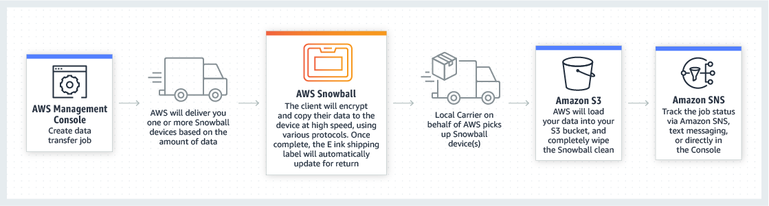

* you **don’t need to write any code or purchase any hardware** to transfer your data.
* Simply **create a job in the AWS Management Console ("Console") and a Snowball device will be automatically shipped to you.**
* Once it arrives, attach the device to your local network, **download and run the Snowball Client ("Client") to establish a connection**, and then use the Client to **select the file directories that you want to transfer** to the device.
* The **Client will then encrypt and transfer the files** to the device at high speed.
* Once the transfer is complete and the device is ready to be returned, **the E Ink shipping label will automatically update**
* you can **track** the job status via Amazon Simple Notification Service **(SNS), text messages, or directly in the Console**.

**Advantages:**

* Simple and compatible
* Low cost
* Easy data retrieval
* High speed
* Extremely scalable
* Tamper resistant and secure

**USECASES:**

**Cloud migration:** If you have large quantities of data you need to migrate into AWS.

**Disaster recovery:** To quickly retrieve a large quantity of data stored in Amazon S3.

**Datacenter decommission:** Snowball ensures that your data is securely and cost-effectively transferred to AWS

**Content distribution:** Use Snowball devices if you regularly receive or need to share large amounts of data with clients, customers, or business associates